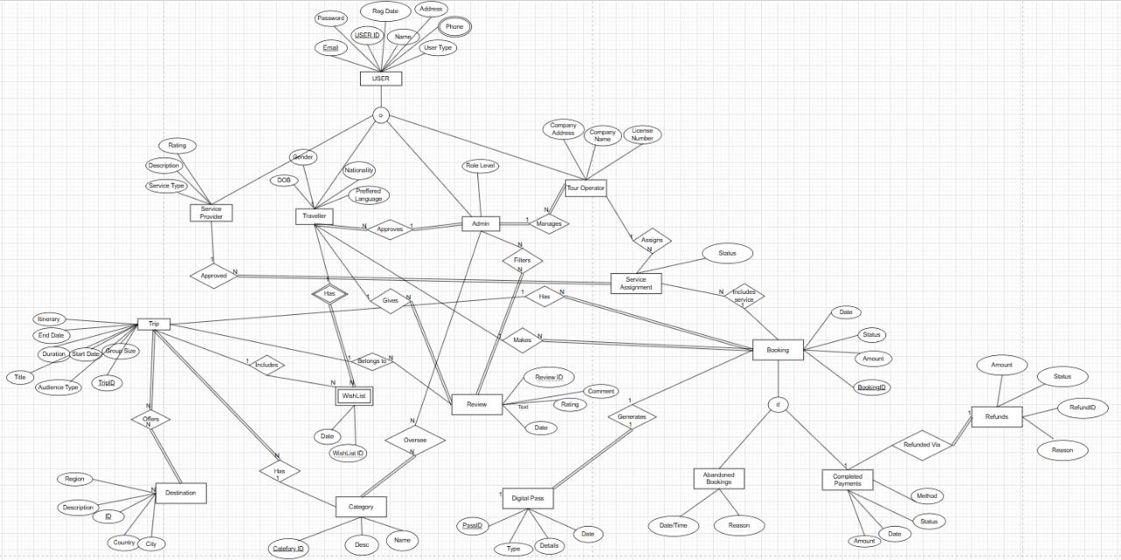Entity Relationship Diagram

Relational Model

# Bold – PK * - FK

* Users(**UserID**, Name, Phone, Address, Email, Password, RegDate, UserType)
* ServiceProvider(**SpID**\*, ServiceType, Description)
* Admin(**AdminID**\*, RoleLevel)
* Traveller(**TravellerID**\*, Gender, DOB, Nationality, PreferredLanguage, AdminID*)
* TourOperator(**TID**\*, CompanyName, CompanyAddress, LicenseNumber, AdminID*)
* Category(**CategoryID**, Name, Descr)
* Trip(**TripID**, Title, CategoryID*, Itinerary, StartDate, EndDate, Duration, GroupSize, AudienceType)
* Destination(**DestinationID**, Country, City, Region, Description)
* TripDestination(**TripID**\*, **DestinationID**\*)
* WishList(**WishListID**, TripID*, TravellerID*, Dated)
* Review(**ReviewID**, Comment, Rating, ReviewDate, TravellerID*, TripID*)
* AdminReviewFilter(**AdminID**\*, **ReviewID**\*)
* AdminCategoryOversee(**AdminID**\*, **CategoryID**\*)
* Booking(**BookingID**, BookingDate, Status, Amount, TravellerID*, TripID*)
* ServiceAssignment(**AssignmentID**, Status, TourOperatorID*, ServiceProviderID*, BookingID*)
* DigitalPass(**PassID**, PassType, PassDetails, IssueDate, BookingID*)
* AbandonedBooking(**BookingID**\*, AbandonDateTime, Reason)
* CompletedBooking(**BookingID** *, PaymentMethod, PaymentDate, PaidAmount)
* Refund(**RefundID**, BookingID*, RefundAmount, RefundStatus, RefundReason, RefundDate)

Details of the Data Base

# **System Overview:**

The **TravelEase** database system has been designed to manage and automate operations for a comprehensive **travel management platform**.  
The system supports **travelers, tour operators, service providers, and administrators** — ensuring smooth handling of bookings, trips, services, and payments.

It covers all real-world requirements mentioned in the project description, with future-proof scalability for reports, analytics, notifications, and more.

# **Key Entities Developed:**

| **Entity** | **Description** |
| --- | --- |
| Users | Stores all users' core information (Travellers, Admins, Service Providers, Tour Operators). |
| Traveller | Specific details of Travelers (DOB, Gender, Nationality, Preferred Language). |
| Admin | System Administrators managing categories, reviews, travelers, and operators. |
| ServiceProvider | Details of service providers like Hotels, Transport, Guides. |
| TourOperator | Companies offering trip packages and managing service assignments. |
| Trip | Trip information including itinerary, audience type, duration, dates. |
| Destination | Cities, regions, and countries attached to trips. |
| TripDestination | M:N relationship between Trips and Destinations. |
| Category | Categories classifying trips (Adventure, Leisure, Cultural, etc.). |
| Wishlist | Trips saved by Travelers for future consideration. |
| Review | Feedback and ratings given by Travelers on Trips. |
| AdminReviewFilter | Admins filtering and managing reviews. |
| AdminCategoryOversee | Admins overseeing Trip Categories. |
| Booking | Details of traveler trip reservations (Completed or Abandoned). |
| ServiceAssignment | Assignment of service providers by Tour Operators to bookings. |
| DigitalPass | E-tickets, vouchers, and activity passes generated after booking completion. |
| AbandonedBooking | Separate tracking of incomplete/canceled bookings with reasons. |
| CompletedBooking | Payment details of fully processed bookings. |
| Refund | Refund processing attached with CompletedBookings. |

# **Key Design Decisions Made:**

* **Unified Users Table:**
  + A single parent table (Users) created, classified by UserType.
  + Related Traveller, ServiceProvider, TourOperator, and Admin as extensions.
* **Booking Status Classification:**
  + Bookings are classified as **Completed** or **Abandoned**.
  + Abandoned bookings handled separately through AbandonedBooking.
* **Service Assignment Management:**
  + ServiceAssignment created to track how TourOperators assign ServiceProviders to Bookings.
  + Covers all services: hotels, guides, transport.
* **Review and Wishlist as Weak Entities:**
  + Review and Wishlist dependent on Traveler and Trip relationships.
* **Payments and Refunds Separation:**
  + Payments split into CompletedBooking and Refund for fine-grained financial tracking.
* **Trip and Destination M:N Relation:**
  + A Trip can belong to multiple Destinations.
  + Managed through a join table TripDestination.
* **Digital Pass System:**
  + Automatically generated after booking confirmation.
  + Supports multiple types: E-tickets, hotel vouchers, activity passes.
* **Audience Types Supported:**
  + Solo Trips
  + Group Trips
  + Corporate Trips
* **Service Provider Types Supported:**
  + Hotels
  + Transport Services
  + Guides
  + Tour Services
* **Abandoned Booking Reason Tracking:**
  + Captures user behavior during incomplete booking flows.

# **Data Population:**

* **Users:** 50–60 diverse users.
* **Travellers:** Major proportion (around 25–30 users).
* **Tour Operators:** About 10 operators (for diverse service management).
* **Service Providers:** 10 high-quality services provided.
* **Trips:** 50+ trips with different durations and categories.
* **Bookings:** Over 100 bookings inserted covering both Completed and Abandoned scenarios.
* **Refunds:** Realistic refunds generated for certain payment failures or trip issues.
* **Service Assignments:** Logical service mapping by Operators to Trips and Travelers.
* **Wishlist and Reviews:** Travelers interacting actively with Trips they like and rate.

# **Integrity Constraints and Rules Applied:**

* **Primary Key** and **Foreign Key** constraints fully maintained.
* **Cascading Updates** and **Deletes** properly configured.
* **Unique Constraints** for Email, License Numbers.
* **Check Constraints** for:
  + Gender values (Male, Female)
  + UserTypes (Traveller, Admin, Service Provider, Tour Operator)
  + Booking Status (Completed, Abandoned)
  + Refund Status (Pending, Completed, Rejected)
  + Audience Types (Solo, Group, Corporate)
* **Default Values** set where required (e.g., preferred language).

# **Scalability and Future Enhancements:**

The database structure is scalable to support:

* Notifications, Reminders, and Marketing Campaigns
* Loyalty Programs and Reward Points
* Real-Time Trip Availability
* Dynamic Trip Pricing
* AI-powered Personalized Trip Recommendations
* Deep Travel Analytics (most booked trips, user behavior, abandoned reasons analysis)

This database design provides a **robust, normalized, and fully relational structure** to support the current and future needs of a modern travel management platform.